**Module-2: GIT Assignment - 1**

Based on what you have learnt in the class, do the following steps:

● Create a new folder

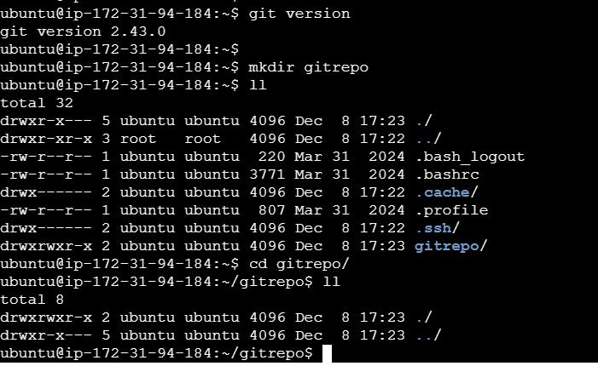

● Put the following files in the folder

○ Code.txt

○ Log.txt

○ Output.txt

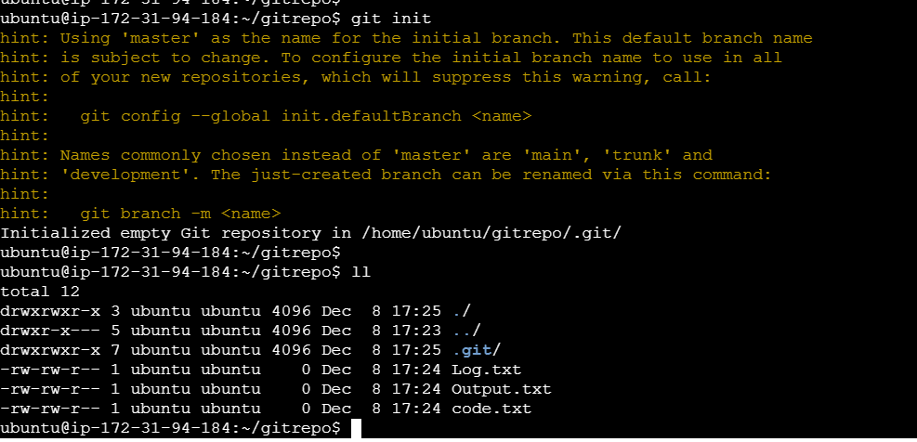

● Stage the Code.txt and Output.txt files

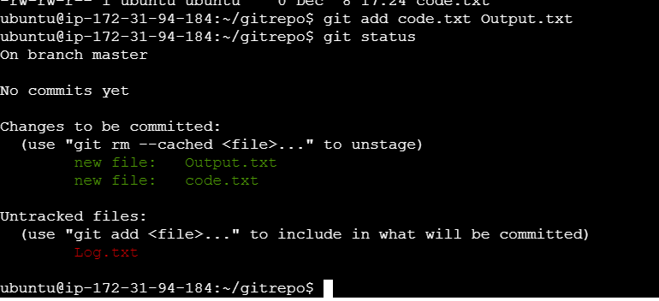

● Commit them

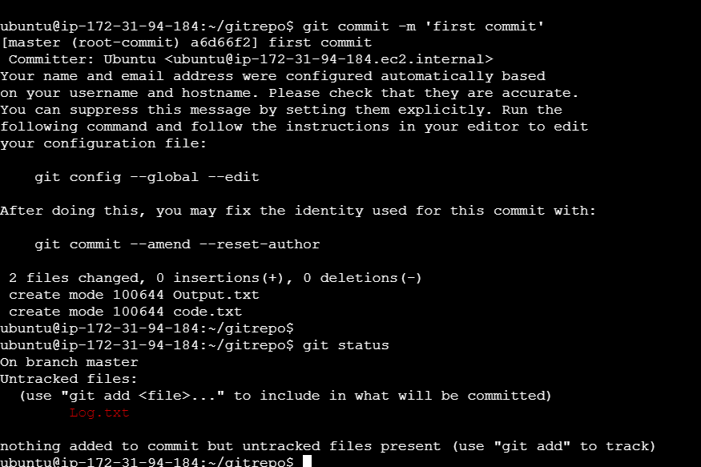

● And finally push them to github

